**Praktik Akses API Melalui Simulasi Wokwi**

*Pelangi Anggel*

Fakultas Vokasi , Universitas Brawijaya

Email: pelangianggel283@gmail.com

**Abstract**

*This study explores API communication between a simulated ESP32 and a Laravel-based REST API using the Wokwi platform. The ESP32 microcontroller is programmed to send JSON data to an API endpoint via WiFi, where the data is processed and stored in a MySQL database. To enable external access, NGROK is utilized to expose the local API.this simulation provides a practical understanding of client-server interactions in IoT, allowing for real time data transmission without physical hardware.*.

*Keywords: SP32, IoT, REST API,Wokwi*

**1. Introduction**

**1.1 Background**

In modern Iot applications, microcontroller often communicate with cloud based system using REST APOs to exchange data efficiently. However, testing API integration usually requires physical hardware, which can be impractical for early development stagea. To address this, the Wokwi simulator is used to emulate an ESP32 communicatng with an API built on laravel. This approach enables testing of API request, response handling, and database integration in a fully virtual environment. Understanding this simulation is crucial for developing real time IoT system that rely on cloud based data management.

**1.2 Objectives**

The objective of this experiment is to simulate Api communication between a virtual ESP32 and a laravel based Rest API to understand client server interactions in IoT application. This experiment aims to establish a wifi connection for to the ESP32 in the Wokwi simulato, send json formatted data to an API endpoint, and store the received data in a MySQL database. Additionally, Ngrok is used to expose the local API to the internet, allowing remote access. By completing this experiment, pasrticipants will gain practical experince in IoT data integration, whis is essential for developing cloud-connected embedded systems.

**2. Methodology**

**2.1 Tools & Materials**

* Wokwi Simulator (ESP32 simulation platform)
* Laravel Framework (API development)
* Ngrok (Public API tunneling)
* MySQL Database (Data storage)
* Code Editor (VS Code/Sublime/PHPStorm)
* Materials:
* ESP32 (Virtual in Wokwi)
* WiFi Network
* REST API Endpoint
* JSON Payload
* These tools and materials are essential for API access simulation via Wokwi.
  1. **Implementation Steps**

1. Run the Laravel API.
2. Create new wokwi simulator file.
3. Change the main.cpp script.
4. Execute the NGROK command.
   * Make sure NGROK gives the URL address in the form (http)
   * Adjust the 8080 port address to the running port of the laravel application
5. Add wokwi.toml file
6. Add diagram.json file
7. Build the main.cpp file and run the simulation
   * Simulation modification by adding temperature and humadity sensors
8. Copy the diagram.json code in vscode
9. Change the settings of the platformio.ini file
10. Modify the main.cpp file
11. Run the simulation
12. Make sure in the database the data has appeard and stored

**3. Results and Discussion**

**3.1 Experimental Results**

|  |  |  |
| --- | --- | --- |
| **Platform** | **Completed Task** | **Key Outcome** |
| Wokwi | API access simulation | The ESP32 successfully sent data to the Laravel API and displayed the response in real-time. |
| ESP32 (Simulated) | Sending JSON data to API | The ESP32 correctly transmitted JSON data via WiFi, and the API processed and stored it in the database. |
| Ngrok | API public access setup | The Laravel API was successfully exposed to the internet, allowing external access from the ESP32. |

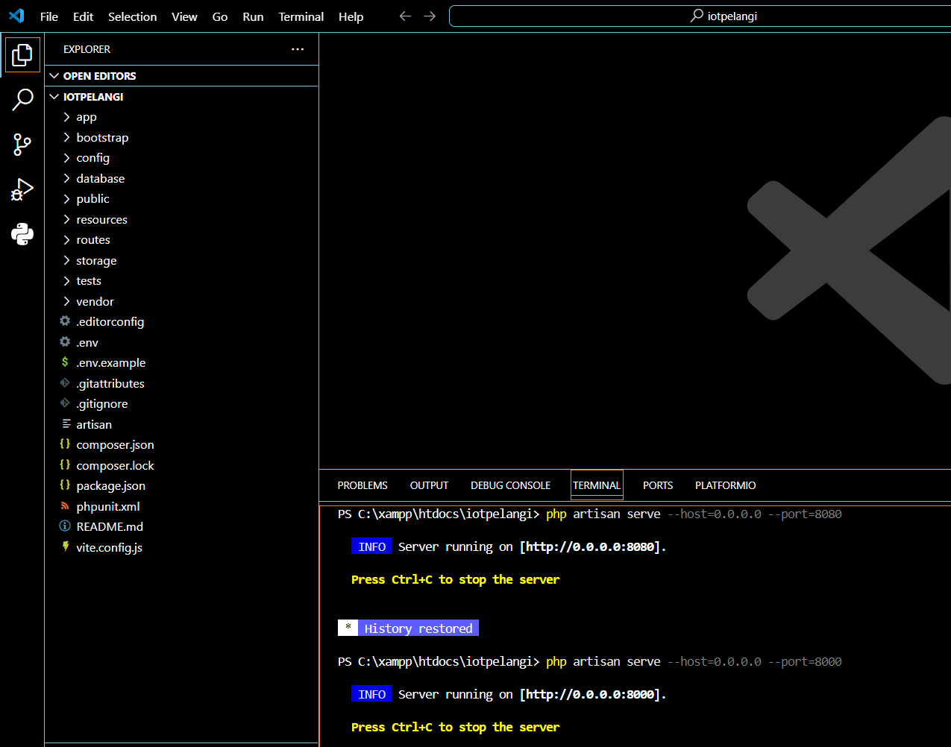

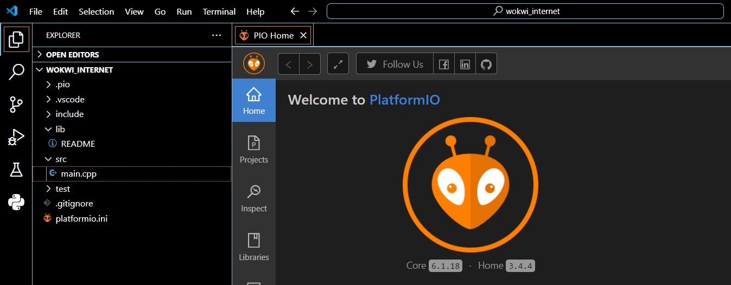

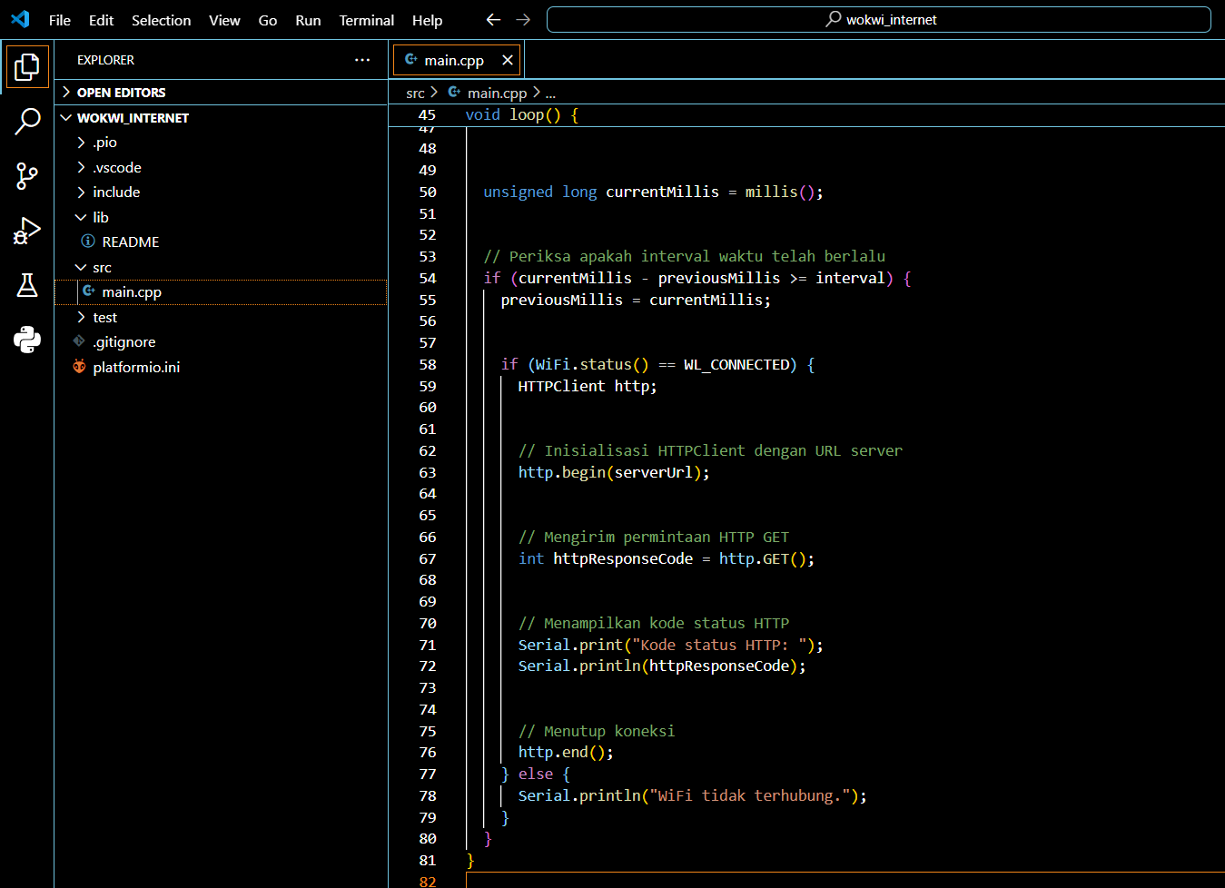

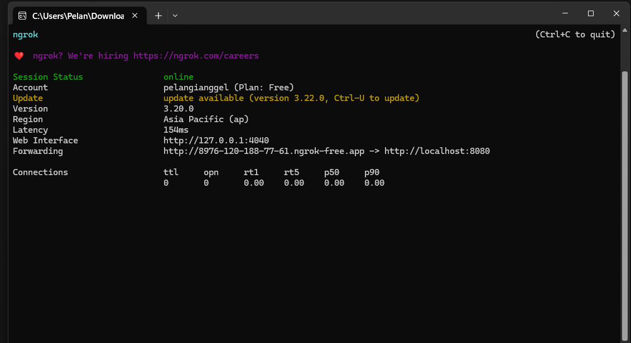

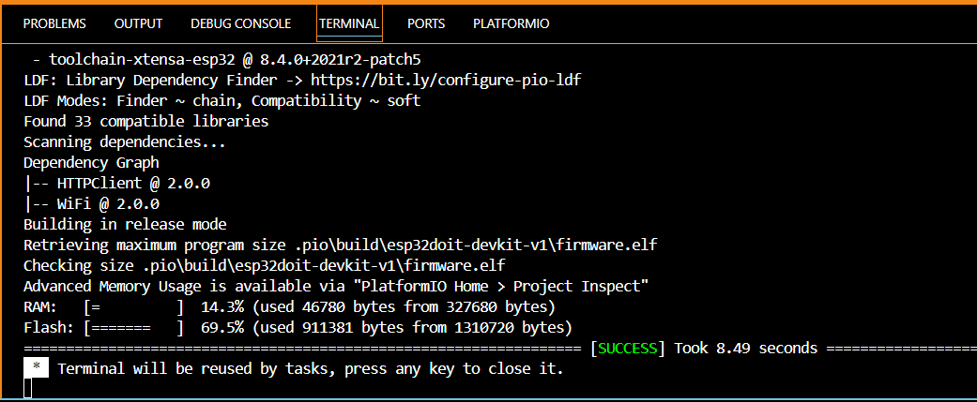

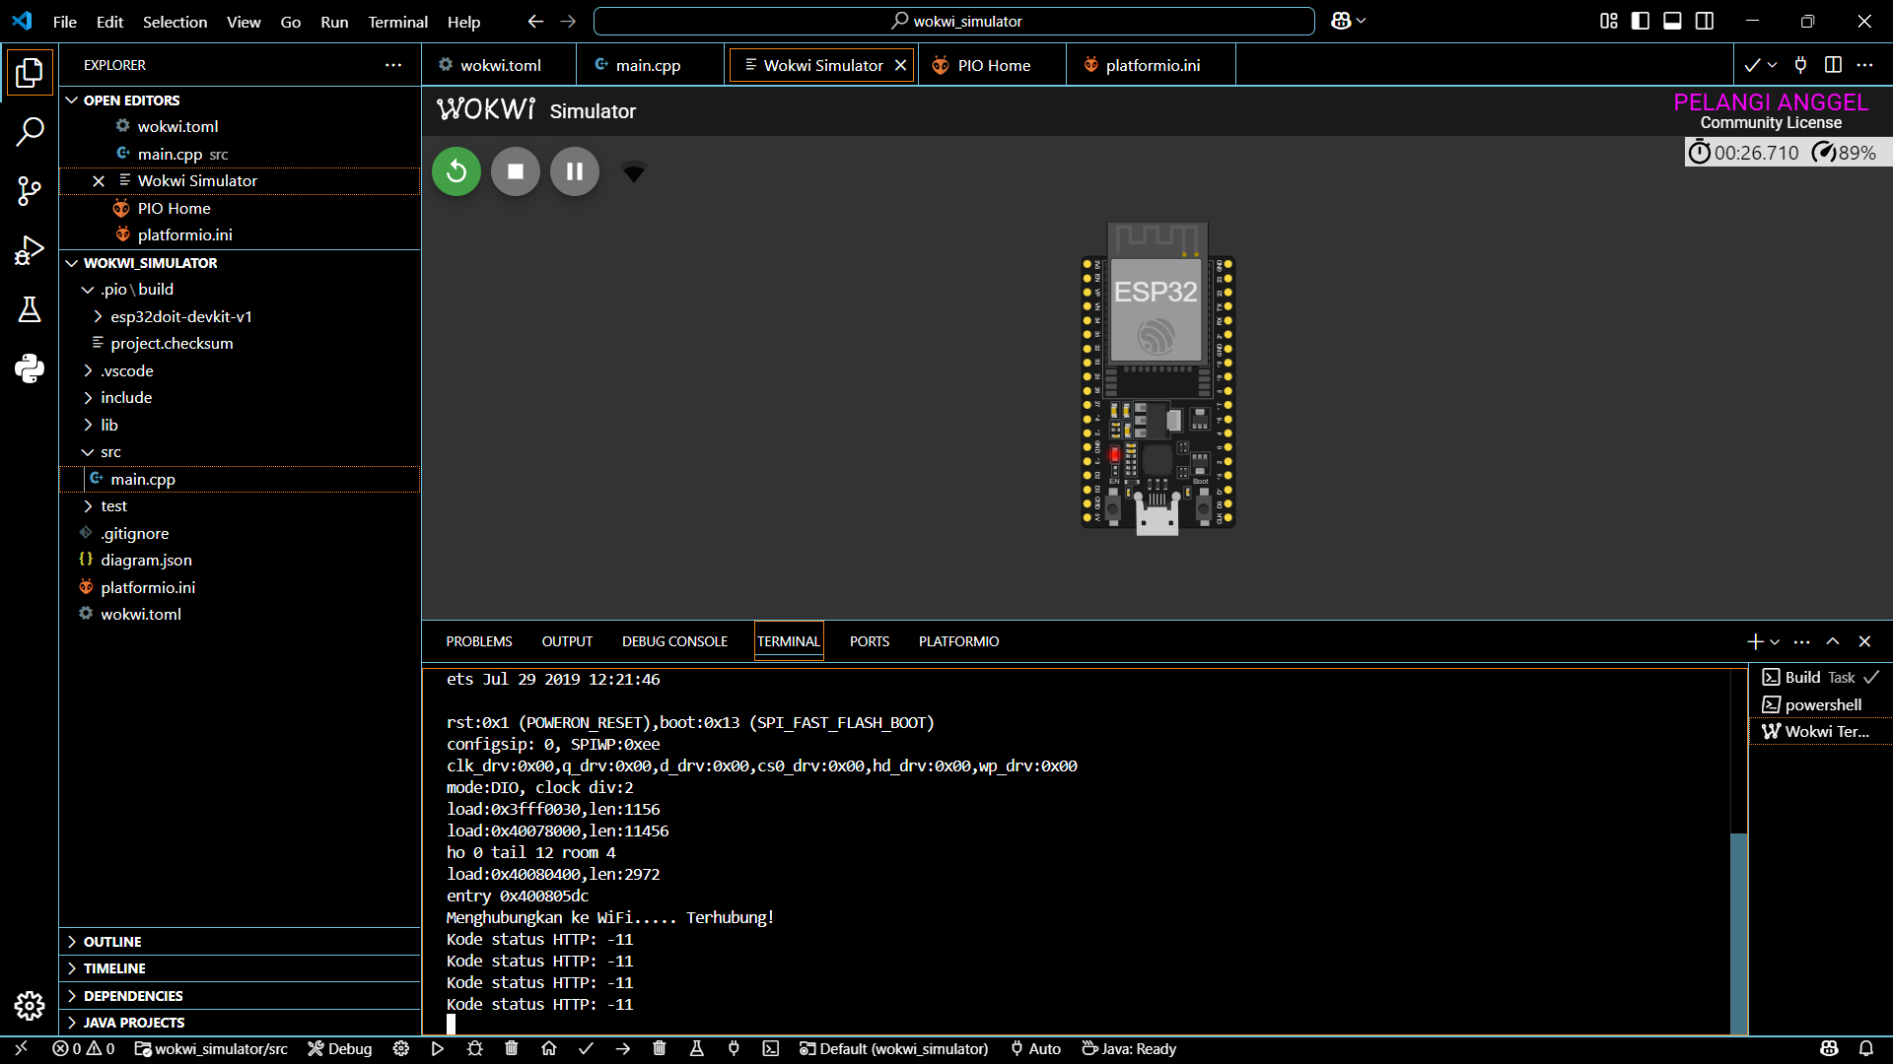 n